ARTSCOPE MAGAZINE MARCH 2014
New England’s culture magazine

CORNERED: LORNA RITZ
Monday, March 3rd, 2014, 5:36 pm
Exhibits, Featured, News, Visual Arts

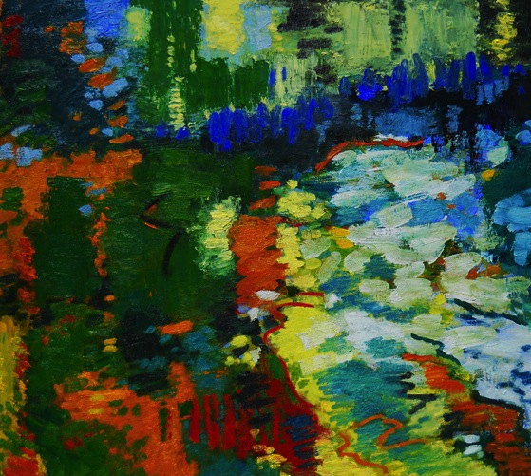

"Ocean, Dunes and Sky," 2013, 30" x 40".

By Brian Goslow
Lorna Ritz has had omnipresence in the Pioneer Valley arts community, both as a painter and publicist, especially with Northampton’s Oxbow Gallery. On the eve of “A Travelogue in Color,” her first Boston solo exhibition that has its opening reception this Wednesday, March 5 from 6:30-8:30 p.m. at the French Cultural Center, 53 Marlboro Street, and where it remains on view through March 31, artscope magazine managing editor exchanged emails with her to talk about the show, breaking into a larger market, her career and inspirations and what to look forward to at the Oxbow and the Northampton/Easthampton/Amherst area this spring.
TELL ME A LITTLE BIT ABOUT “A TRAVELOGUE IN COLOR …”
The paintings in the show exemplify my love of the Impressionist painters who have informed my color sensibilities over time. I lived in France on several occasions for short periods of time. One of the paintings in the show, “Ocean, Dunes and Sky,” was done in Provincetown, where I had a grant to live in a shack for CScape last April, without electricity of running water. I did drawings ‘on site’ and came back to Amherst where I painted the canvas.
DESCRIBE YOUR WORK FOR THOSE WHO HAVEN’T HAD A CHANCE TO SEE IT …
I consider my abstract paintings to be landscapes without direct reference to anything recognizable in nature, while the drawings clearly show sky, clouds, mountains and trees. The paintings come out of the drawings.
WHO ARE YOUR MAJOR INFLUENCES?
I have steeped myself in the 19th century French painters that have deepened my daily practice as an abstract expressionist, ‘impressionist’ painter. The Impressionist painters enmeshed themselves in “seeing,” through a concentration of color relationships. Over decades I have studied and been influenced by the French Impressionist painters, by their paintings, drawings, sculptures, writings, journals, sketchbooks and architecture as seen in the museums of Paris, well documented in my writings and in my photographs from when I visited the Impressionist Museums in Paris, and taught at the American University in Aix en Provence, in Cezanne’s studio.
I became aware what the artists from France endured in order to keep their craft and skill evolved over time, through wars and poverty, adversity clearly reflected in their paintings, and how a select few eventually made their way to America, such as Matisse, Mondrian and Kokoshka. I have interest in those European painters and writers live once they transitioned to America and how abstract expressionism came directly out of Impressionism.
HOW HAS PREPARING FOR A BOSTON SHOW DIFFERED FROM GETTING READY FOR A SHOW IN YOUR HOME REGION WHERE YOU’RE FAIRLY WELL KNOWN?
A student recently asked me if I ‘was famous.’ I answered, “On my street I am.” Every artist here (in Western Mass.) knows every other artist here. I am not well known in Boston, coupled with the fact the trend for young painters ‘now’ is more technically borne, conceptually conceived. There is a whole new younger generation of very creative artists from all over the world whose tools are anything but oil paint on canvas. While they expand my ways of thinking and I learn from them, when I am 95, they will say, “Can you believe there is still an easel painter left?”
Very few Boston or NYC galleries exhibit abstract expressionist painters, of which I am third generation, four decades of developing the concepts that began, for me, under the painter James Gahagan (jamesgahagan.com). Jim was a student of Hans Hofmann. I have taken the paintings in my own direction, because ‘I’ am living ‘Now,’ in the 2014th year, with new things to say.
WHAT WAS THE BIGGEST CHALLENGE IN GETTING READY FOR YOUR BOSTON SHOW? SOUNDS LIKE YOU WERE LUCKY TO FIND SOMEONE TO ASSIST IN YOUR JOURNEY …
Boston has the worst drivers and traffic. Getting paintings on the highway always makes me nervous. My paintings did not fit in my Jeep by 4 inches. An angel showed up with a van at the last minute. A painting undergraduate student at UMASS who is interning under me told me she wanted to know how to set up a show. “Well, sure!” I said. Packing therefore was easy, something she did not know how to do. So I got to hear my voice explaining things as I was making choices all along the way.
She was referred to me to learn about the ’life of a painter.’ Well, she came to the right place — She wants to learn how to write grants, how to build a canvas, stretch it, prime it, construct a frame, and how to set up a show by sequencing the paintings, which are some of many things I have shown her. We talked about all aspects of painting all the way to Boston and back, and she studied the myriad of paperwork involved between the curator and me at the gallery. We discussed mundane subjects such as publicity and press release writing. I told her travel stories, as in ‘the gift of gab,’ that I did not even remember I had until conversation triggered a memory, and then I wanted to go back to that country to have the experience all over again.
YOU PUT A LOT OF WORK INTO PROMOTING YOUR ART AND THE ART OF OTHERS. MOST DO NOT DEVOTE THEMSELVES TO MARKETING THEMSELVES TO THE EXTENT YOU DO. WHERE DID THIS ATTITUDE COME FROM — AND HOW HAS — AND HASN’T — IT PAID OFF?
I have been doing the Oxbow Gallery press releases for artists for years now, and got good at it — surely no one else wanted this job — which has made it easier for me to promote my own shows, as well as advise artists when they have their shows at other galleries. I often volunteer my skills, to help them. Most artists are not organized, but I am, to a fault. I like to see things get done right, on time and accurately. Even my studio is organized.
HOW LONG HAVE YOU BEEN AFFILIATED WITH THE OXBOW GALLERY AND HOW IT FARED THIS WINTER — AND HOW ARE THE “ARTS NIGHT OUT NORTHAMPTON,” HELD ON THE SECOND FRIDAY OF EACH MONTH, FARING IN TERMS OF ATTRACTING BOTH LOCAL AND OUT-OF-TOWN AUDIENCES?
I am an ‘alumni member’ of the Oxbow Gallery now, showing there more rarely, and having more shows elsewhere. But the gallery is doing great, and I remain the publicity person for the gallery. The shows are well attended and have many great painters showing there. I am proud to be affiliated with the gallery. Arts Night Out is a great concept and many people come and not just locally.
YOU’VE BEEN FOCUSED ON THE FRENCH CULTURAL CENTER OPENING; HAVE YOU HAD TIME TO KEEP WORKING ON NEW PAINTINGS — AND IF SO, WHAT DIRECTION ARE THEY TAKING?
Painting is the first and foremost most important thing in my life, and the evolution of it through a constantly expanding visual vocabulary that life experience ‘always’ brings to my work.
(“Lorna Ritz: A Travelogue in Color” can be seen from March 1-31 at the French Cultural Center, 53 Marlborough Street, Boston, Mass.; the opening reception is on Wednesday, March 5 from 6:30-8:30 p.m. “Lorna Ritz: The Holyoke Range: Mountains Like Ocean Waves” can be seen from March 14 through April 4 at Historic Northampton, 46 Bridge Street, Northampton, Mass. A solo show of Ritz’s work will be on view from April through June at the Aidron Duckworth Art Museum, 21 Bean Road, Meriden, New Hampshire. For updated details, please visit lornaritz.com.)

